Click and type your title here. Capitalize the initial letter of the first word only. The title must be brief and grammatically correct. Avoid abbreviations
B first Author^{1,2}, G second Author¹ and B Author^{1,2,}*
¹Malabar Heights, Tupti University, Chennai 600 020, India
²Institute of Knowledge, Tumkur 600 020, India
*Author for correspondence (Anami89@gmail.com)
MS received
Abstract. Type your abstract text here. All manuscripts must be accompanied by an abstract which briefly summarizes the reasons for the work, the experimental plans, the main results and conclusions of the study. The optimal length is one paragraph (100–250 words). Since the abstract is indexed in many databases it should be self-contained without any undefined abbreviations or any cited references.

Keywords. Basket; ball; wound dressing; microscopy; scaffold.

1. Introduction
Lorem ipsum dolor sit amet, consectetur adipisicing elit, sed do eiusmod tempor incididunt ut labore et dolore magna aliqua [1]. Ut enim ad minim veniam, quis nostrud exercitation ullamco laboris nisi [2–5] ut aliquip ex ea commodo consequat. Duis aute irure dolor in reprehenderit in voluptate velit esse [3–8] cillum dolore eu fugiat nulla pariatur. Excepteur sint occaecat cupidatat non proident, sunt in culpa qui officia deserunt mollit anim id est laborum [5,6,9–15].
Lorem ipsum dolor sit amet, consectetur adipisicing elit, sed do eiusmod tempor incididunt ut labore et dolore magna aliqua. Ut enim ad minim veniam, quis nostrud exercitation ullamco laboris nisi ut aliquip ex ea commodo consequat. Duis aute irure dolor in reprehenderit in voluptate velit esse cillum dolore eu fugiat nulla pariatur. Excepteur sint occaecat cupidatat non proident, sunt in culpa qui officia deserunt mollit anim id est laborum [16].
2. FIRST-LEVEL HEADING
2.1 Second-level heading
Chitosan (low molecular weight), poly(vinyl alcohol), sodium tri-poly phosphate, ciprofloxacin HCL, Dulbecco’s modified Eagle’s medium (DMEM), fetal bovine serum (FBS) and the supplementary antibiotics for tissue culture were purchased from SigmaAldrich, India. The mouse NIH 3T3 fibroblast and human (HaCaT) keratincy cell line was obtained from the National Centre for Cell Science (NCCS), Pune, India.
2.2 Second-level heading
2.2a Third-level Heading: Lorem ipsum dolor sit amet, consectetur adipisicing elit, sed do eiusmod tempor incididunt ut labore et dolore magna aliqua. Ut enim ad minim veniam, quis nostrud exercitation ullamco laboris nisi ut aliquip ex ea commodo consequat. Duis aute irure dolor in reprehenderit in voluptate velit esse cillum dolore eu fugiat nulla pariatur. Excepteur sint occaecat cupidatat non proident, sunt in culpa qui officia deserunt mollit anim id est laborum [16].

2.2b Third-level Heading: Lorem ipsum dolor sit amet, consectetur adipisicing elit, sed do eiusmod tempor incididunt ut labore et dolore magna aliqua [17]. Ut enim ad minim veniam, quis nostrud exercitation ullamco laboris nisi [2–5] ut aliquip ex ea commodo consequat. Duis aute irure dolor in reprehenderit in voluptate velit esse [3–18] cillum dolore eu fugiat nulla pariatur. Excepteur sint occaecat cupidatat non proident, sunt in culpa qui officia deserunt mollit anim id est laborum (figure 1) [18].
A constant size [19–41]. The equilibrium ratio was calculated by using the following equation.

(1)

Where w₀ = 2 and w₁ = 25.
3. Results and discussion
3.1 Fourier transform infrared spectroscopy
veniam, quis nostrud exercitation ullamco laboris nisi ut aliquip ex ea commodo consequat. Duis aute irure dolor in reprehenderit in voluptate velit esse cillum dolore eu fugiat nulla pariatur, see figure 2 and table 1. Excepteur sint occaecat cupidatat non proident, sunt in culpa qui officia vibrations.
4. Conclusion
Aamet, consectetur adipisicing elit, sed do eiusmod tempor incididunt ut labore et dolore magna aliqua. Ut enim ad minim veniam, quis nostrud exercitation ullamco laboris nisi ut aliquip ex ea commodo consequat. Duis aute irure dolor in reprehenderit in voluptate velit esse cillum dolore eu fugiat nulla pariatur. Excepteur sint occaecat cupidatat non proident, sunt in culpa qui officia deserunt mollit anim id est laborum.
Acknowledgements
We thank Mr. Lorem ipsum dolor sit amet, consectetur adipisicing elit, sed do eiusmod tempor incididunt ut labore et dolore.
Electronic supplementary material
Supplementary material pertaining to this article is available on the Bulletin of Materials Science website (www.ias.ac.in/matersci).
References
- Sonnrte A and Phgfgd A 2003 J. Mol. Liq. 78 5
- Croisier F and Jerome C 2015 Eur. Polym. J. 9 080
- Alhhjkhjk X, Flin Y, Rndwu I and Qinglu E 2015 J. Bioact. Compat. Pol. 220 15
- Inis A D, Dlliams E C and Knskiy L V 2018 Biomacromolecules 90 37
- Shioi-Hcnsnui H, Ysxu-Bopin V, Caahing-Lsin T, Kescscng-Yesxcn F, Ssxshu-Huda Wssang, Hwqefesiang-Jung T et al 2011 Colloid Surf. 85 98
- Maaarguerite Rwveinaudo 2016 Prog. Polym. Sci. 301 1603
- Zsceng-Xwciao C, Sivagscsnanam T, Ramasaanathan A, Kamal raja C, Shantham X, Kiom P et al 2012 Int. J. Mol. Sci. 101 29
- 1Olscs F, Pre B and Robot G 1998 Drug Dev. Ind. Pharm. 24 979
- Pdvdariya S and Nainkorn 2018 J. Min. Met. Mat. S 180 735
- Yursxi C and Ravi M 2013 Ceram. Int. 39 4937
- Jie B, adss M, Jss D, jekuun N, kadsdx P, w2wea T et al 2007 Solid State Commun. 141 292
- Wg D, Fscu X and Yansxag L 2007 Chin. Sci. Bull. 352 883
- Yunying T 2014 Int. J. Pharm. 378 30
- Vivi V 2011 Adv. Drug Deliver Rev. 623 5847
- Hars R, LeSSi E, Mateos-Aparicio I, MeSngibar M and Heras A 2011 Carbohyd. Polym. 8C4 8013
- Kooasper V, Wilscsliams V W, Kyanskiy W V, Ram E, Sagara M, Zam M et al 2017 Biochim. Biophys. Acta 18 7255
- Amaair E, Esdbrahim F and Moham R 2018 Iranian J. Pharm. Sci. 45 1711
- Thalu M, Vhinam B and DfeSastry X 2003 Colloid Surf. B1202 62294
- Wazxaed S, A, Raj S and Joshi S 2011 Carbohyd Polym. 803 48
- Yoxng-Tassng J 2007 Carbohyd. Polym. 167 c403
- Andrew N M 2016 Ph D Thesis (St. Louis: Washington University)
- Ram F, Sinlu S, Ra M D, Lsciji D, Sob l, Tialli U and Sanam E 2004 J. Biomater Tiss. Eng. 14 2dc03
- Nadvsn N, Giiprasath R and Uma T S 2013 Polym. Tech. 32 21370
- Naveen 2013 Int. J. Polym. Mater. 63 583
- Nickel N H and Terukov E 2005 (eds) Zinc oxide—a material for micro- and optoelectronic applications (Netherlands: Springer)
- Giripr R 2017 RSC Adv. 62 7914
- Kandh S, Ramanathan G, Kadaa J, Bal R, Matsdsan N, Sgnanam U T et al 2018 RSC Adv. 52 55075
- Sudhamani S R, Prasad M S and Udaya Sankar K 2003 Food Hydrocolloid. 17 245
- Ansadsitha D, Sdshantha L and Fsaraju 1896 Carbohyd. Polym. 8 2143
- Pang Y and Lodewijks G 2012 Proceedings of 9th IEEE international conference on networking, sensing and control New York, USA p 79
- Ramesh, M R 2004 U.S. Patent 392422, March 15
- Telma, B, Raquel, V, Teresa C and Ana A-R 2014 J. Supt. Fluid 94 102
- Young M and Mahesh R 1996 J. Appl. Polym. Sci. 62 901
- Liu Y, Vrana N E, Cahill P A and McGuinness G B 2009 dsv Biomed. Mater. Res. B Appl. Biomater. 90 492
- Ana R and Naresh P 2014 J. Bioact. Compat. Pol. 29 137
- Al Bosta M, Ma K J and Chien H H 2013 J. Ceram. Article ID 350931 doi: 10.1155/2013/350931
- Jayanth P and Kumar 2003 J. Control Rel. 92 173
- Cherng J, Kim P and Lee I 1992 Pharm. Res. 9 10
- Sudesh K and Doi Y 2005 in C Bastioli (ed) Handbook of biodegradable polymers (Shawbury: Rapra Technology Ltd) p 219

- Pelino Mario and Cantalini Carlo 1994 Bull. Mater. Sci. 16 69
- Artphop N, Neeracha S, Prasit P, Ratana R and Pitt S 2008 Eur. Poly. J. 44 2060

Tables
Insert tables with caption here.

Table 1. Values as estimated.
Number (N) | Quantity (kg ml^{–1}) | Volume (m mol^{–2}) | Average (%)
Object 1 | 200 | 10 | 10.10
Object 2 | 25 | 0.30 | 10.25
Object 3 | 150 | 2.50 | 10.50

Figures
Insert figures here

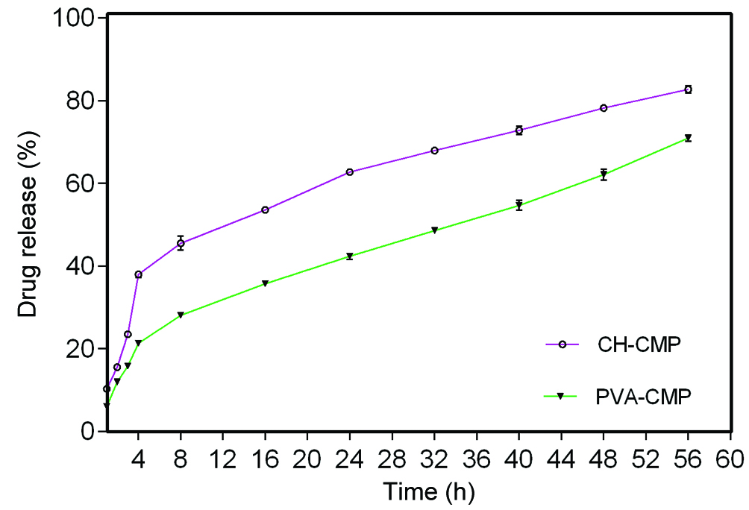
Figure 1. Curves of the LLOY.

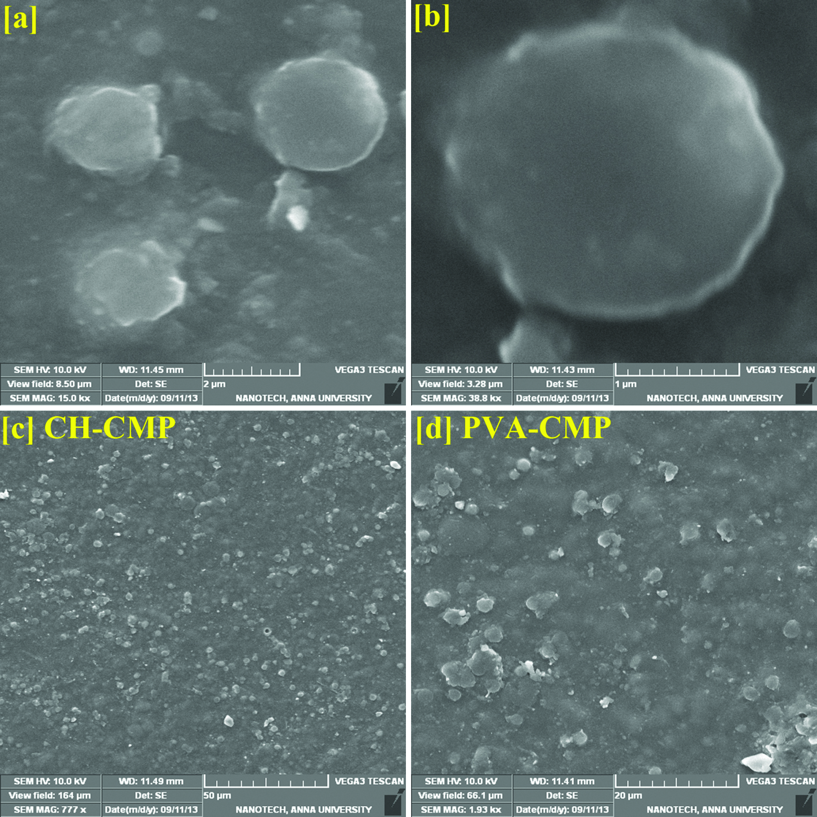

Figure 2. Sascascascasc.
NOTE:

- Before submitting your manuscript, you need to delete all of the instructions and examples from the template that are not needed. Make sure that all pages have page numbers. Ensure that all parts of the manuscript are presented clearly.
- If it is possible, please provide a set of high resolution Schemes, Equations, Figures and Tables along with your manuscript.
For more instructions on how to prepare and submit your manuscript, please see our web page at http://www.ias.ac.in/matersci.

